1. 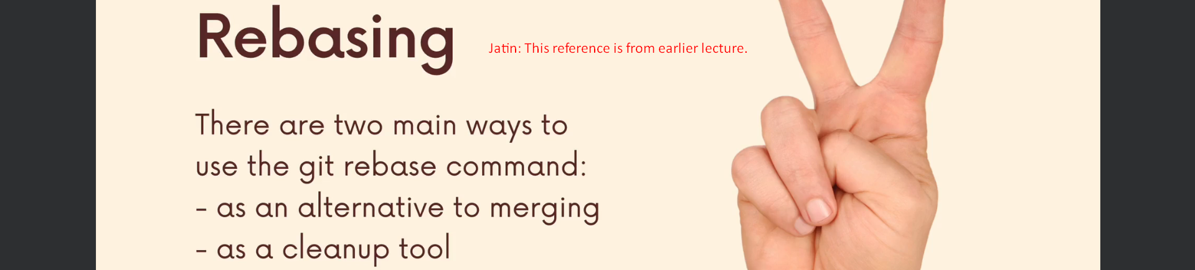
2. 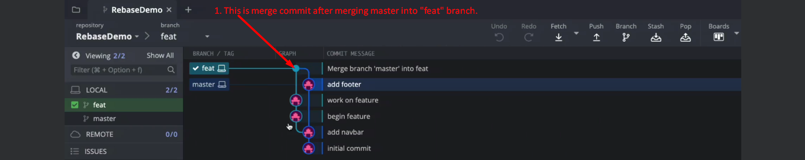
3. 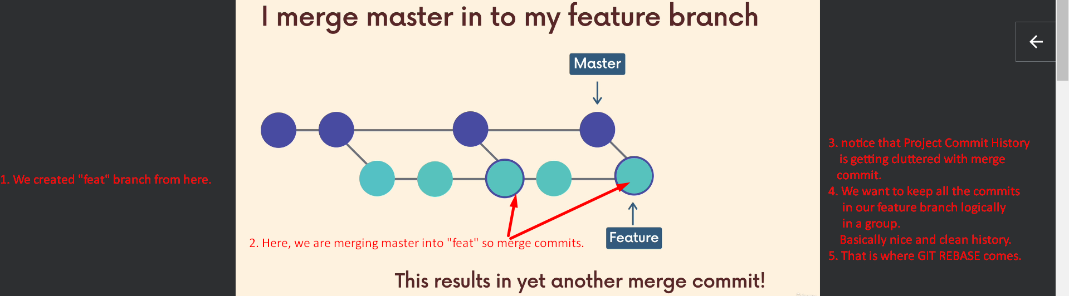
4. In next lecture, we will see how to use rebase for nice and clean history.